SOLUTION DESIGN DOCUMENT
Apex Property Operations
Custom Salesforce Application for Property and Maintenance Management
Author | Sharon Chidzere
Role | Salesforce Administrator
Document Type | Solution Design Document
Version | 1.0
Status | Draft
Date | 19 March 2026

1. Executive Summary
Apex Property Operations is a custom Salesforce application designed to centralise and streamline property and maintenance management workflows. This document outlines the business problem, solution design, data model, functional requirements, and user stories that define the scope and structure of the implementation.

Objective | To create a Salesforce-based solution that enables a property operations team to manage properties and maintenance workflows more efficiently through custom objects, automation, and reporting.

Scope | Custom objects, object relationships, page layouts, automation rules, and reporting dashboards within a Salesforce Developer Org.

2. Background & Business Problem

2.1 Background
Property management teams often deal with multiple moving parts simultaneously: tracking properties, logging maintenance issues, assigning work, following up on repairs, and keeping records up to date. When these activities are managed manually through spreadsheets, emails, or separate systems, it becomes increasingly difficult to monitor progress, maintain data accuracy, and respond quickly to issues.

Apex Property Operations was designed to bring these processes into one central Salesforce system.

2.2 Business Problem
A property operations team needs a better way to:
- manage property records in one place
- log maintenance issues against specific properties
- assign work to technicians or contractors
- track work progress from initial report through to completion
- improve visibility across open jobs and current statuses
- reduce manual admin and missed follow-ups

Without a structured system, teams may face:
- duplicated or incomplete records
- delays in assigning or resolving issues
- limited reporting on outstanding work
- poor visibility across properties and maintenance activity

3. Users & Roles
The solution is designed to support the following user groups:

User Role | Responsibilities
Property Operations Staff | Manage property records and oversee maintenance activity
Maintenance Coordinators | Log requests, create work orders, and monitor progress
Technicians / Contractors | Carry out assigned work and update task statuses
Management | Review performance, workloads, and outstanding maintenance issues via reports and dashboards

4. Data Model & Key Objects
The solution is centred around the following Salesforce objects and their relationships:

Object | Type | Purpose | Key Fields
Property | Custom | Central record representing a managed property | Property Name, Address, Type, Owner, Status
Maintenance Request | Custom | Logs an issue or maintenance need against a property | Request Type, Priority, Status, Reported Date, Property (Lookup)
Work Order | Custom | Manages the repair or service activity for a request | Technician, Scheduled Date, Estimated Cost, Status, Request (Lookup)
Service Task | Custom | Breaks down a work order into individual actions | Task Description, Task Status, Duration, Assigned To, Work Order (Lookup)
Account | Standard | Represents property owners, letting agents, or contractor companies | Standard Account fields
Contact | Standard | Represents property owners, tenants, and stakeholders | Standard Contact fields

4.1 Object Relationships
The object hierarchy follows a clear parent-child structure:
- Account / Contact (Standard) — linked to Property as owner or stakeholder
- Property (Custom) — the central record; all maintenance activity is tracked against it
- Maintenance Request (Custom) — Lookup to Property; one property can have many requests
- Work Order (Custom) — Lookup to Maintenance Request; one request can generate one or more work orders
- Service Task (Custom) — Lookup to Work Order; each work order can be broken into multiple tasks
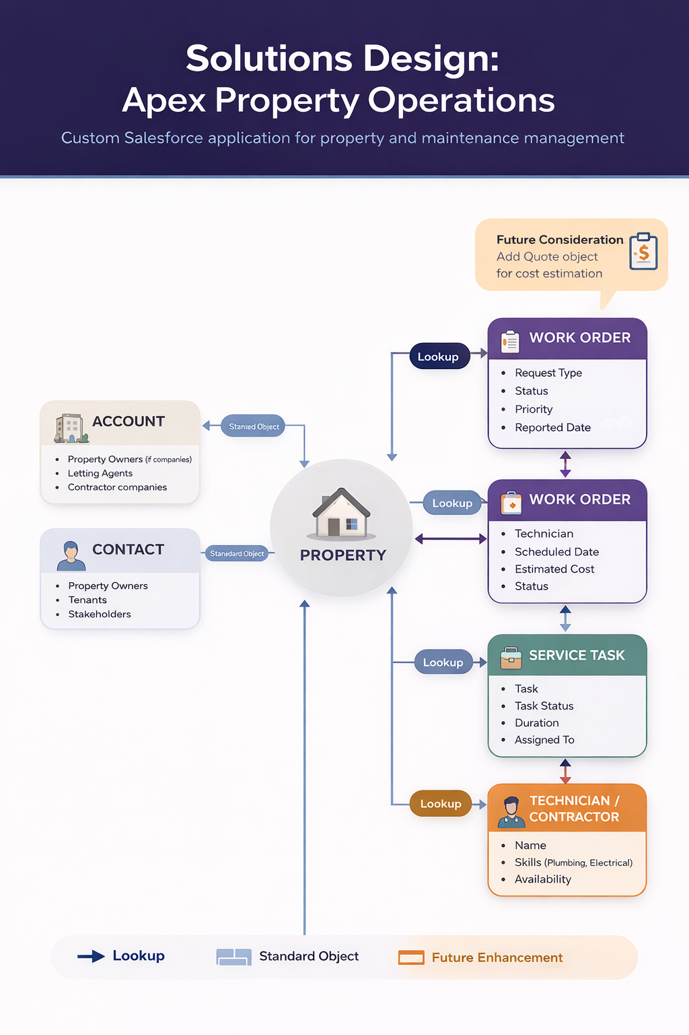

5. Process Overview
The end-to-end operational process within the system follows these steps:

- A property record is created and maintained in Salesforce
- When an issue is reported, a Maintenance Request is logged against the property
- A Work Order is created to manage the repair or service activity
- The work can be broken down into Service Tasks if needed
- Staff track status, assignments, and completion dates throughout the process
- Reports and dashboards provide visibility into open requests, overdue work, and operational activity

6. Functional Requirements
The system should allow users to:
- create and manage property records
- log maintenance requests against a property
- capture request details such as type, priority, and status
- create work orders linked to maintenance requests
- assign work to technicians or contractors
- break work into smaller service tasks where needed
- update statuses as work progresses
- report on outstanding and completed maintenance work

7. User Stories
The following user stories define the core functional requirements from each user's perspective:

User Story | Role | Goal | Value
US-01 | Property Operations Coordinator | Log a maintenance request against a property | All property issues are tracked in one place
US-02 | Maintenance Coordinator | Create a work order from a maintenance request | Repair work can be assigned and monitored
US-03 | Technician / Contractor | See the service tasks linked to a work order | Work can be completed in a structured way
US-04 | Manager | View reports on open requests and work order statuses | Workload and service performance can be monitored

8. Solution Summary
Apex Property Operations uses custom Salesforce objects and relationships to create a structured operational process:

Object | Role in Solution
Property | Acts as the central record — all activity is anchored here
Maintenance Request | Captures issues reported for a property
Work Order | Manages the actual repair or maintenance job
Service Task | Tracks the individual actions required to complete the work

This design creates a clear hierarchy and supports better visibility, cleaner data, and more efficient operations.

9. Business Value
This solution provides value by:
- improving organisation of property and maintenance data
- reducing reliance on manual tracking methods
- increasing visibility of active and completed work
- supporting more efficient job assignment and follow-up
- enabling future automation and scalability

10. Future Enhancements
The following enhancements are identified as potential next phases:
- Quote object to support cost estimation prior to work order creation
- Automation rules to auto-assign work orders based on technician skills and availability
- Email notifications to contractors when a work order is assigned
- Approval process for high-priority or high-cost maintenance requests
- Customer portal (Experience Cloud) for tenant-facing request submission

Note | Future enhancements are out of scope for the current implementation but have been identified to demonstrate awareness of platform capability and scalability planning.

